S228/999



DUBLIN INSTITUTE OF TECHNOLOGY
_____________

DT228/1 BSc. (Honours) Degree in Computer Science

Year 1
______________

SUMMER EXAMINATIONS 2015/2016
______________

Microprocessor Systems [CMPU1019]

Mr. Frank Duignan
Dr. Deirdre Lillis

Wednesday 18th may 4.00 p.m. – 6.00 p.m.

Two Hours

Answer 3 out of the following 4 questions.
Numbers prefixed by 0x are in hexadecimal.

In addition to the DIT Approved List of Calculators (Use of Calculators in Examinations),
the following calculator models are also permitted for this examination:

Casio fx-991es | Casio fx-991es PLUS
Sharp EL-520X | Sharp EL-520W
Sharp EL-W506 | Sharp EL-W506x
Question 1

(a) If the following C-code is compiled using a 32 bit compiler and then executed what will it print to the screen?
Note: The %X format string causes a value to be printed in hexadecimal (capital letters)

#include <stdio.h>
int main()
{
printf("\n%X\n",0xa08457ce ^ 0x7e29e921);
printf("\n%X\n",0xffff & (~0x0ff2));
}
[4 marks]

(b) Determine the signed 16 bit result of the following signed 16 bit calculation and explain why it is wrong. (Numbers are in base 10)
-32766 - 3 [4 marks]

(c) A microcontroller has a communications link that operates at 9600 bps. There is a communications overhead such that it takes 10 bits to send an 8 bit (byte) value. How long will it take to transfer 1 KiB over the link? [6 marks]

(d) What is the decimal numeric range of:
(i) unsigned 16 bit numbers [2 marks]
(ii) signed 8 bit numbers [2 marks]

(e) A microcontroller has a 10 bit Digital to Analogue Converter (DAC). The DAC can output
voltages in the range 0 to 3Volts
(i) List two applications of DAC's [4 marks]
(ii) A C function is available called WriteDAC(int Value). The function parameter is an integer that fits into the 10 bit range of the DAC. If the function is passed a value of 290, what voltage be output by the DAC?
[5 marks]
(f) Using suitable sketches, explain how the storage of data differs in Little and Big “Endian” systems. [6 marks]

Question 2
(a) Port 0 of the LPC1114 is associated with two registers : GPIO0DIR and GPIO0DATA. State the function of each of these registers [4 marks]

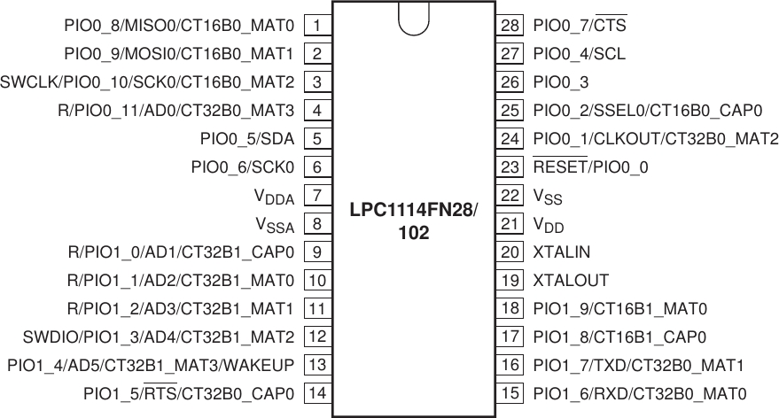
Figure Q2a

(b) Figure Q2A shows the pinout for an LPC1114 microcontroller. Assuming all pin configuration has been performed previously, answer the following:

(i) An application program is required to set pin 1 high without changing the state of the other pins. What line of C-code would you use to achieve this? [4 marks]

(ii) An application program is required to set pin 28 low without changing the state of the other pins. What line of C-code would you use to achieve this? [4 marks]

(iii) An application program is required to toggle pin 14 without changing the state of the other pins. What line of C-code would you use to achieve this? [4 marks]

(iv) An application program is required to wait for pin 26 to go high without knowing the state of the other pins. What line of C-code would you use to achieve this? [4 marks]

(c)
char egetc()
{
while ((U0LSR & BIT0)==0); // wait for data
return U0RBR; // return contents of Receive Buffer register
}

void readString(char *String, int Max)
{
int Index;
char ch;
while ( (Index < Max-1) && (ch != '\n') )
{
ch = egetc();
if (ch != '\n')
{
String[Index++]=ch;
}
}
String[Index]=0;
}
Listing Q2a

Listing Q2a shows part of a serial communications driver for an LPC1114 microcontroller.
(i) The egetc function polls (reads) the line status register (U0LSR) waiting for data to arrive. Why is this a poor use of the CPU? [4 marks]

(ii) Suggest a more efficient alternative to polling the line status register. [3 marks]

(iii) An application program calls readString as follows:
readString( str, 4);
and the serial interface receives “Hello\n”
What are the contents of str on return from readString? [6 marks]
Question 3
(a)
(i)What are the differences between the actions of a compiler (or assembler) and a linker [4 marks]
(ii) What is an assembler directive? Illustrate your answer with an example. [4 marks]
(b) Outline three ways programs typically use the stack in computer programs [6 marks]
(c) What is the principal function of the following ARM Cortex M0 registers?
(i) PC [2 marks]
(ii) LR [2 marks]

(d) Listing Q3a shows an LPC1114 assembler listing for a function to find the length of a string.
(i) What does each line do function do between Line A and Line B? [9 marks]
(ii) Assuming the stack is empty to begin with and register SP contains 0x20001000, where are the contents of R1,R2 and LR copied to on entry to the function? [6 marks]

; int strlen(char *str)
; This function takes a single argument: a pointer
; to a string in R1. It searches through the
; string looking for a terminating null, counting
; as it goes. This count is returned as the
; length of the string to the caller via R0.
;
strlen
push {LR} ; save any registers that are changed
push {R1} ; (apart from R0)
push {R2}
MOVS R2,#0 ; clear out R2
; <-------LINE A
MOVS R0,#0 ; R0 will be our counter, start at zero
strlen_loop
LDRB R2,[R1] ;
CMP R2,#0 ;
BEQ strlen_exit
ADDS R0,R0,#1 ;
ADDS R1,R1,#1 ;
B strlen_loop ; back to top of loop
; <-------LINE B
strlen_exit
pop {R2}
pop {R1}
pop {PC}

Listing Q3A

Question 4
(a) What ARM Cortex M0 Arithmetic flags are set by the following calculations
(i) 4-4 [2 marks]
(ii) 0xffffffff+2 [2 marks]
(iii) 1-2 [2 marks]
(iv) 0x8000000-2 [2 marks]

(b) The ARM Cortex M0 core has the following conditional branch instructions:

Instruction | Flags tested | Meaning
BEQ | Z = 1 | Branch if equal
BNE | Z = 0 | Branch if not equal
BCS | C = 1 | Branch if higher or same (unsigned)
BHI | C = 1 and Z = 0 | Branch if higher (unsigned)
BCC | C = 0 | Branch if lower (unsigned)
BLS | C = 0 or Z = 1 | Branch if lower or same (unsigned)
BMI | N = 1 | Branch if Negative
BPL | N = 0 | Branch if Positive or zero
BVS | V = 1 | Branch if (signed) overflow
BVC | V = 0 | Branch if no (signed) overflow
BGE | N = V | Branch if greater or equal (signed)
BLT | N != V | Branch if less than (signed)
BGT | Z = 0 and N = V | Branch if greater (signed)
BLE | Z = 1 and N != V | Branch if less than or equal (signed)
B |  | Branch always

Which of these conditional branches will work with the C code examples below (justify your answer):
(i)
int a,b;
if (a > b) goto label1 [4 marks]

(ii) unsigned a,b;
if (a<=b) goto label1 [4 marks]

(c) The ARM Cortex M0 is a 32 bit processor. Using suitable assembly language code show how you can add two 64 bit numbers on this processor [7 marks]

(d)
(i) Describe the interrupt handling mechanism in the LPC1114. Your answer explain how the processor finds the instructions to execute in response to an interrupt and how it returns to the pre interrupt state [7 marks]
(ii) The ARM Cortex M0 has a built-in 24 bit down-counter called systick which can be used to generate periodic interrupts. If the clock speed of the processor is 48MHz, what is the slowest interrupt rate that can be achieved using this counter? [4 marks]

